# Visualisation of Force Fields

In the paper by Goyal, Runia (Wear, 1991), limit surfaces are discussed representing the net frictional force and the moment between a rigid body and the surface on which it slides. Below we try to analyse these surfaces for few trivial cases and then for continuous surface patches.

The surfaces are defined by the contact points and the friction strength at those points, then a reference point is chosen C. The limit surfaces are then generated for each case.

## 1 Single contact point

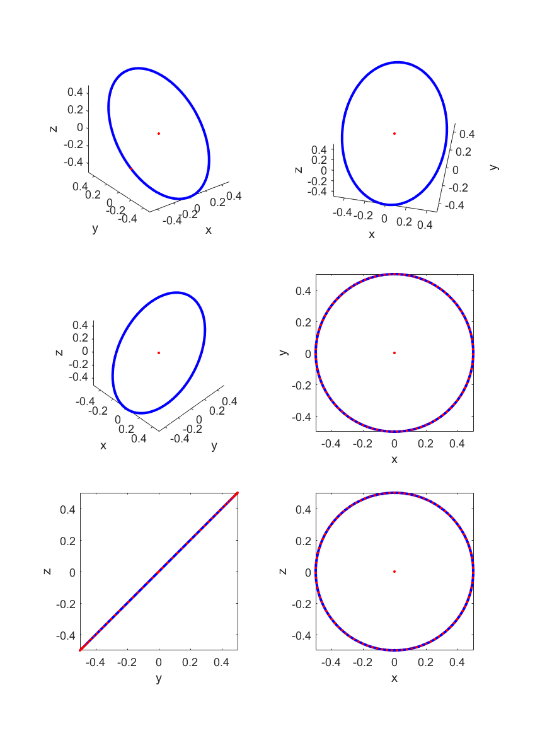

C(0,0)

A(1,0)

## 2 Two-point contact

A(0,1)

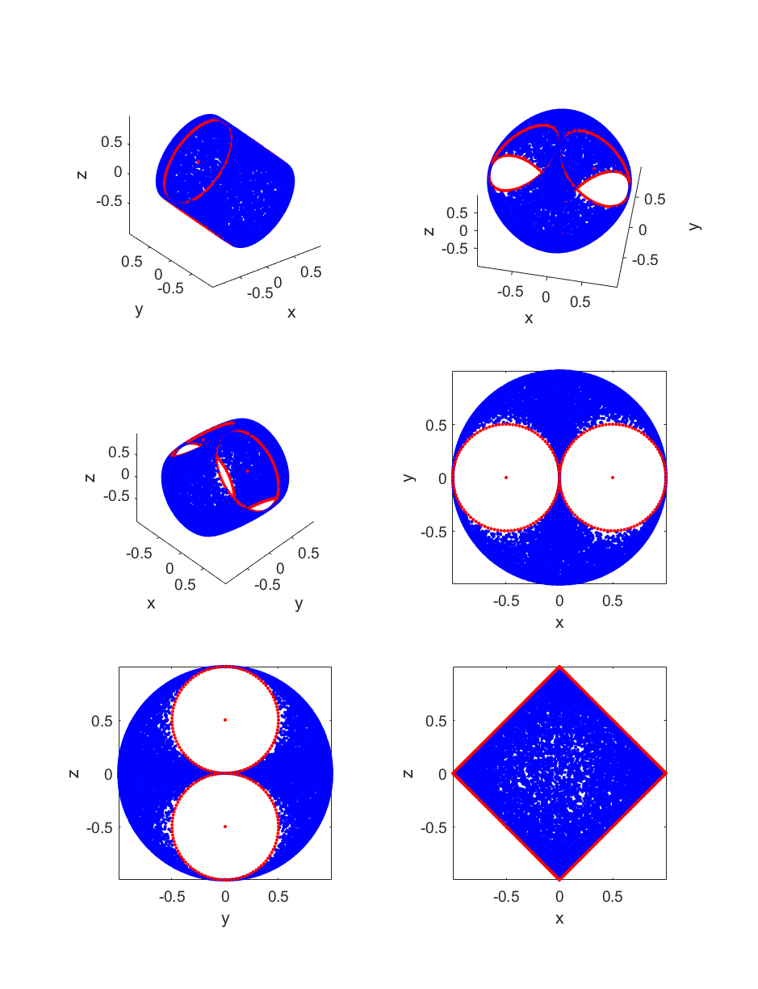

C(0,0)

B(0,-1)

## 3 Triangle

D

C(0,0)

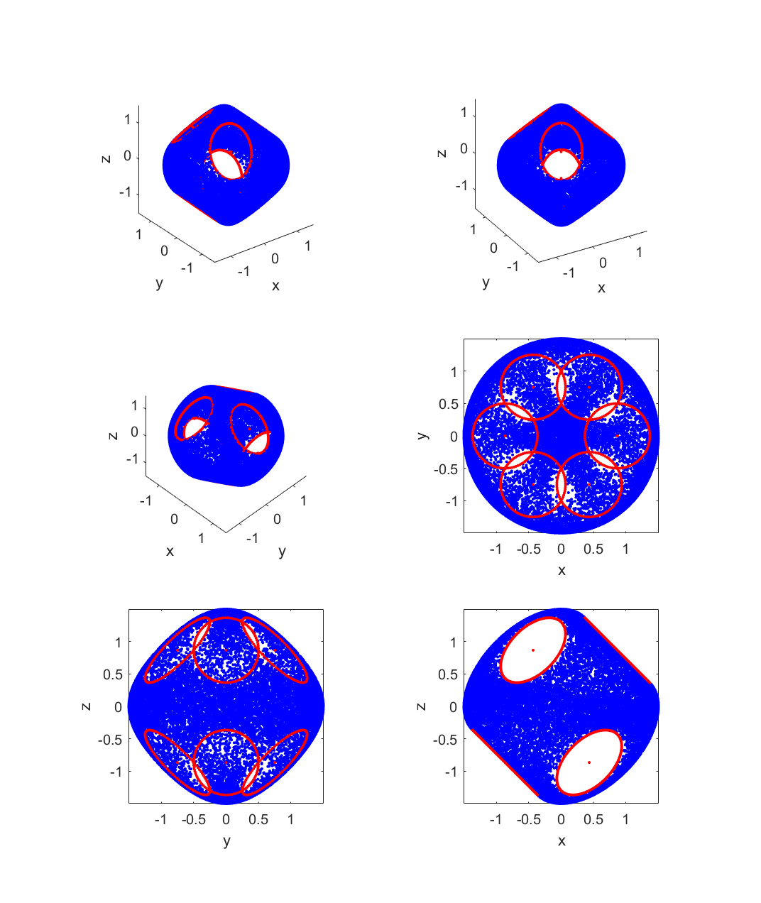

A

B

## 4 Square

E(1,1)

B(-1,1)

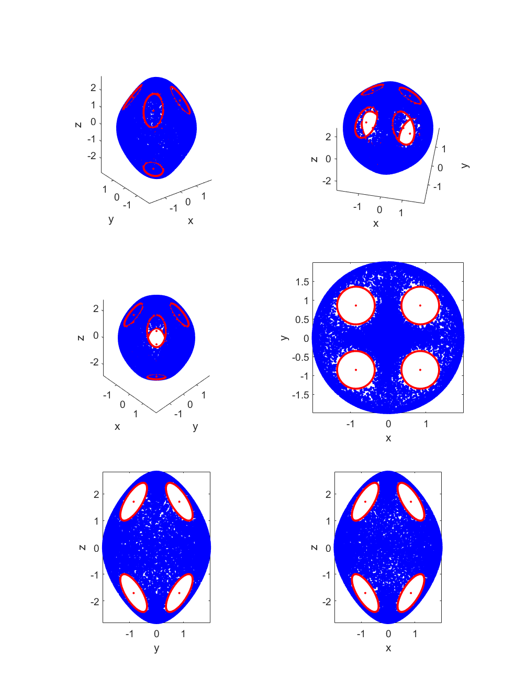

D(1,-1)

A(-1,-1)

C(0,0)

## 5 Continuous surfaces (Triangle)

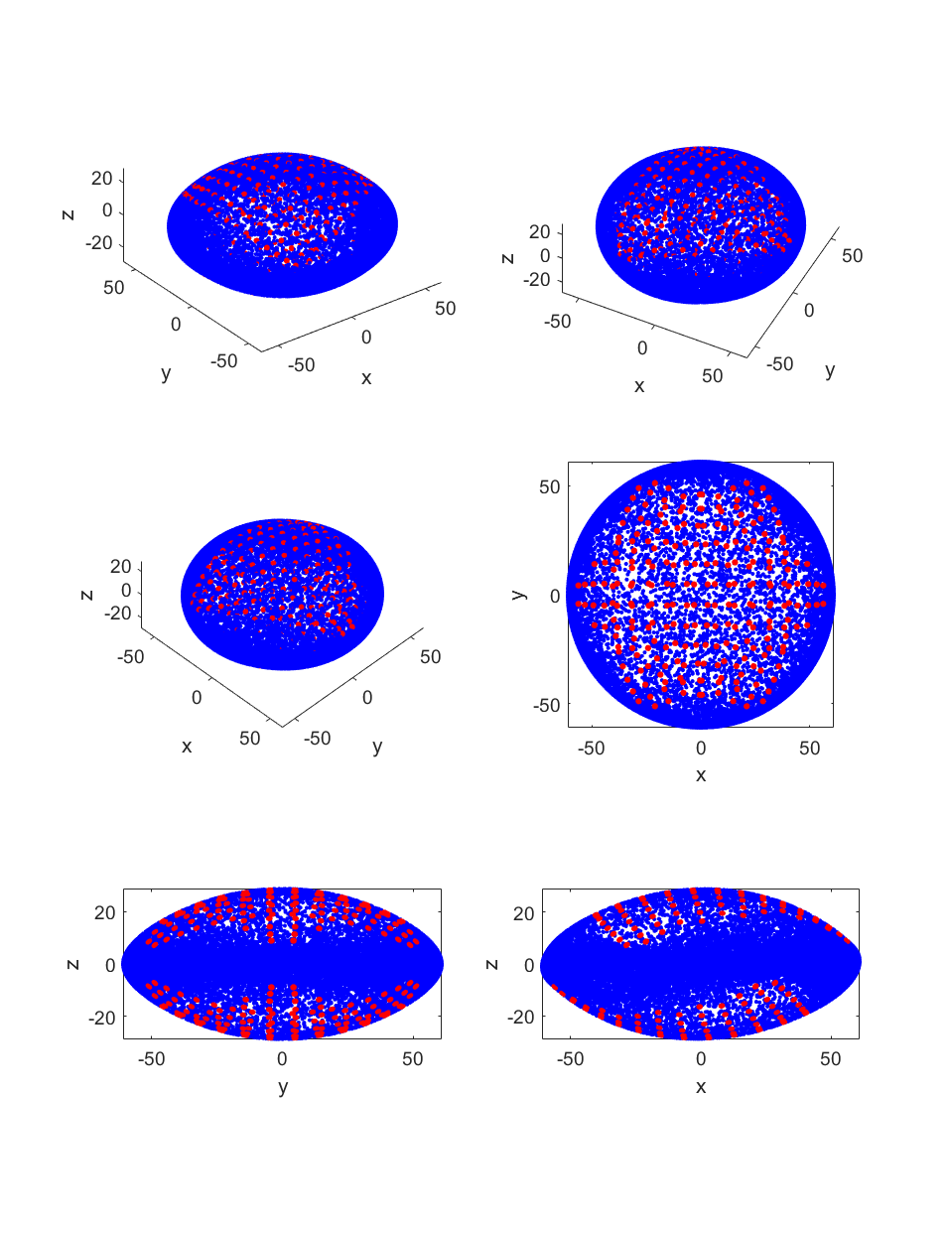

## 6 Continuous surfaces (Square)

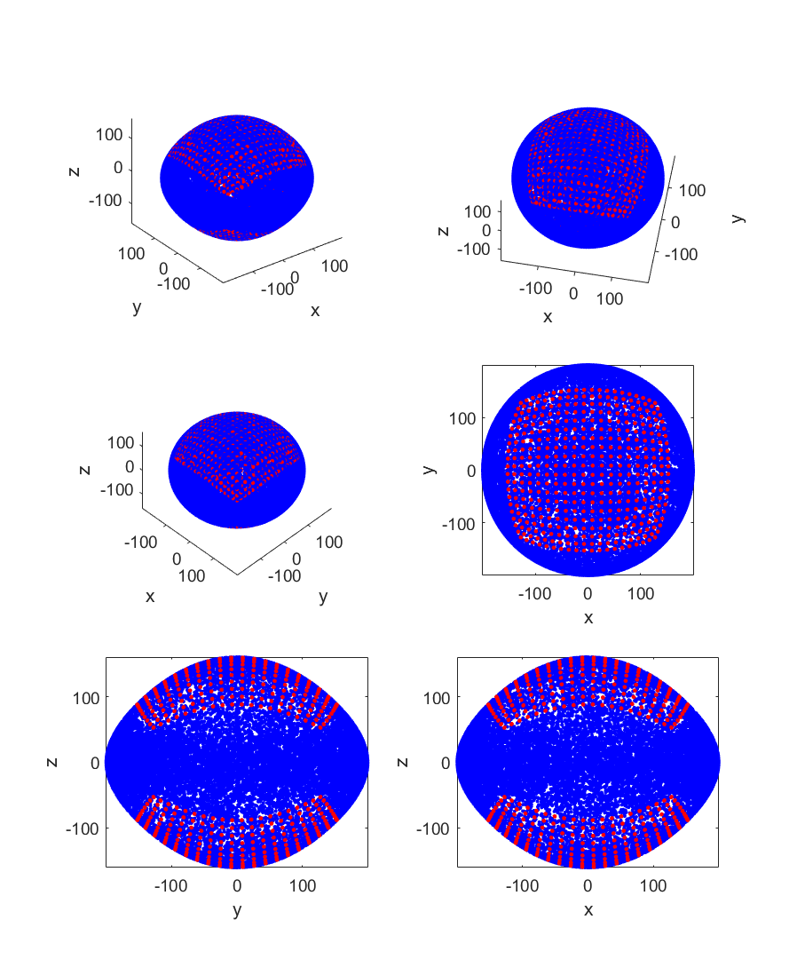

## 7 Continuous Surface (Randomly distributed square)

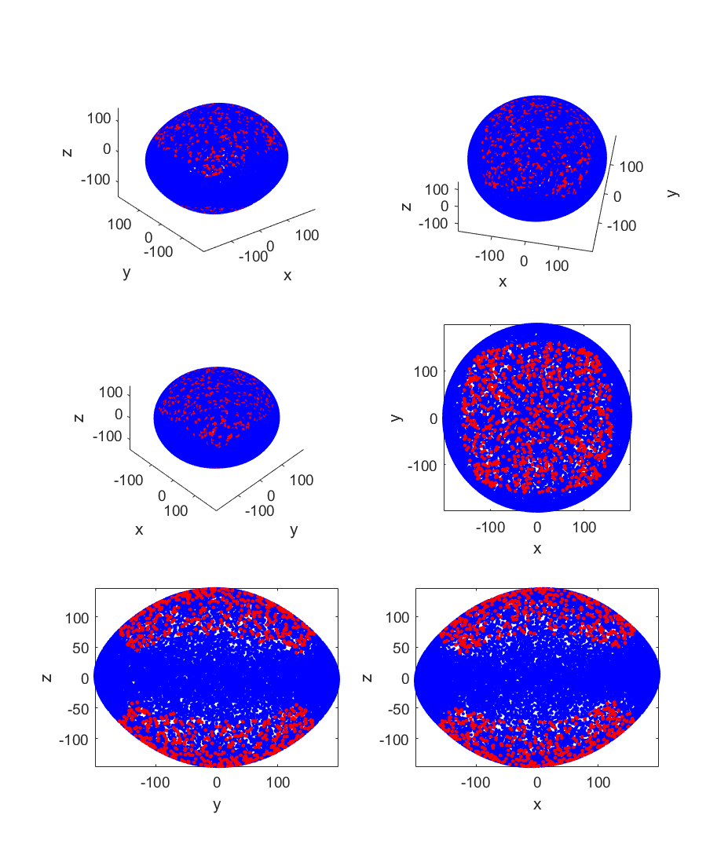

# Approximation of Force Fields

We chose the following objective function to get a fit. The following are the objective functions with increase in terms of the approximation. We will consider upto 3 terms in our analysis.

$$E=\sum_{k=0}^{n}{{{{(f}^{'}}_{k}Af_{k}-1)}^{2}}$$

$$E=\sum_{k=0}^{n}{{{{(f}^{'}}_{k}A{f^{'}}_{k}+{{{(f}^{'}}_{k}Bf_{k})}^{m}-1)}^{2}}, m is chosen as 0.5$$

$$E=\sum_{i=0}^{n}{{{{(f}^{'}}_{k}A{f^{'}}_{k}+{{{(f}^{'}}_{k}Bf_{k})}^{m1}+{{{(f}^{'}}_{k}Cf_{k})}^{m2}-1)}^{2}}, m1=\frac{1}{3}, m2=\frac{2}{3}$$

Here $f$ is a force vector from the Force field data and A,B,C are matrices that are found by minimizing the objective function E.(using fminunc in MATLAB)

Now that A,B,C are known, let $α$ be some number such that $αf$ causes slip, i.e:- $αf$ resides on the limit surface. Therefore $αf$ must follow the following condition-

$$α^{2}f'Af=1, for 1 term approximation$$

$$α^{2}f'Af++{(α^{2}f'Bf)}^{m}=1, for 2 term approximation$$

$$α^{2}f'Af+{{(α}^{2}f'Bf)}^{m1}+{{(α}^{2}f'Cf)}^{m2}=1, for 3 term approximation$$

Values for $α$ can be found from the above equations.

Approximations found are plotted below-

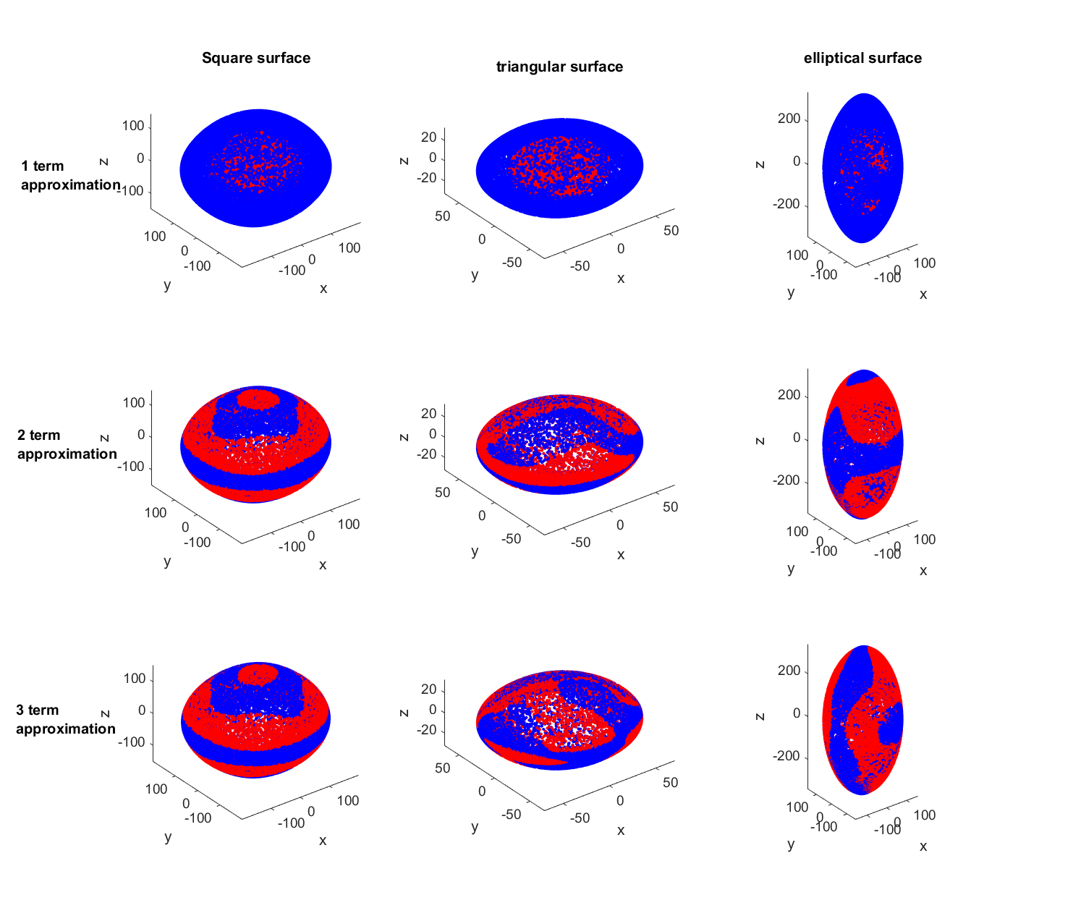Fig1. Different approximations for different cases (Blue-original, Red-approximation)

The above figure shows upto three term approximation of limit surfaces for three different continuous surfaces, square, triangular and elliptical. The blue surface is the original data and the red surface is the approximated surface.

It can be observed the approximation gets better with increase in the number of terms in the approximation and can also be verified with the error data from the data below.

The following were the error values :-

|  |  |  |  |
| --- | --- | --- | --- |
|  | Square | Triangle | Ellipse |
| 1 term | 25.24 | 17.15 | 35.85 |
| 2 terms | 0.86 | 2.05 | 12.36 |
| 3 terms | 0.44 | 0.35 | 4.59 |